Political Structure – Information Sheet Name:__________________________

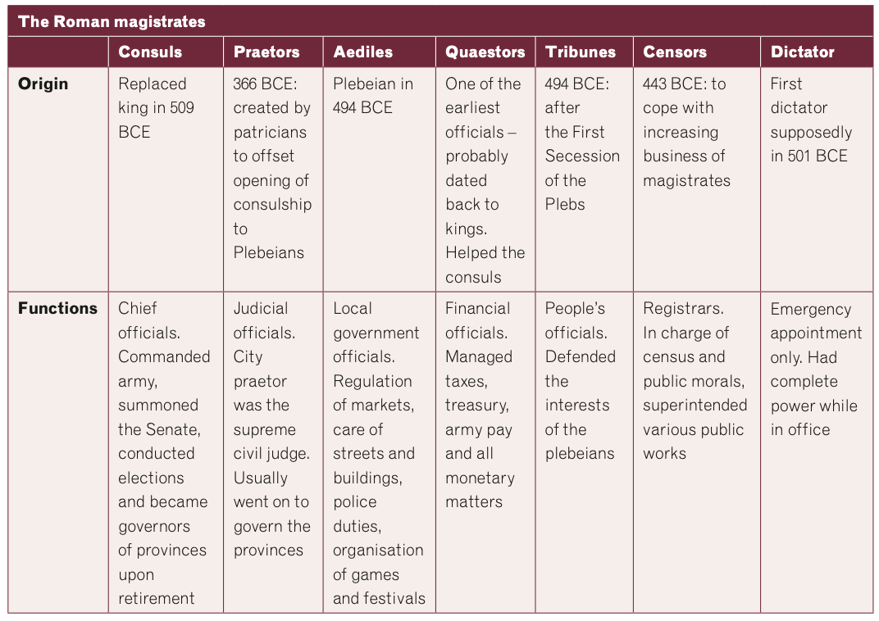

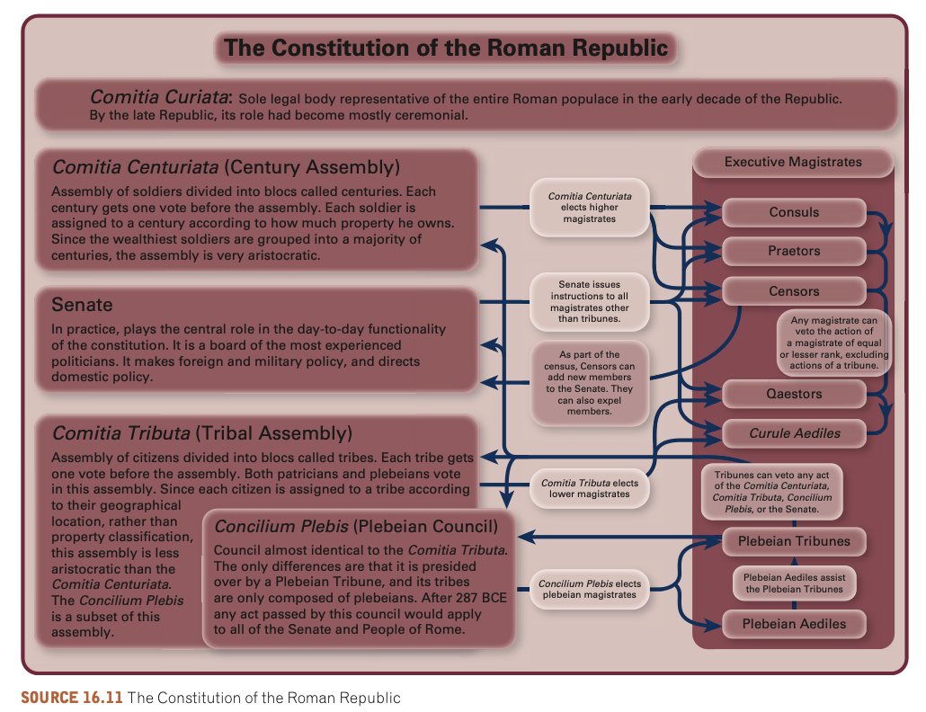

Using table 16.1, which details functions of various magistrate positions and the *cursus honorum* dia- gram, complete the following questions.

1. Why do you think the number of praetors and quaestors increased but the other magistracies **r**emained constant?
2. Decide which magistrate would have dealt with the following situations:
   1. collecting taxes from a new province
   2. keeping a register of contracts
   3. paying the soldiers and generals in the army
   4. allocating work gangs to fix holes in the road
   5. accepting the responsibility of governing a province
   6. selecting participants for the gladiatorial games
   7. registering the birth of a new baby
   8. appealing against a proposal not in the best interest of the people
   9. judging civil disputes between citizens
   10. leading the army in times of military crisis
   11. implementingsenatorialdecisions
   12. expelling a senator for lax morality
   13. nominating an older person for a position as senator
   14. classifying people in order to determine political rights and military duties.

3. Do you believe the political structure/system is efficient and fair? Why/why not?